CS 314: Operating Systems Laboratory
Assignment 7

Ashwin Waghmare
210010060

Part 1
1) A virtual address generated by a process is in bound if VA<Limit
For seed 1, bound (Limit) = 290
Serial No. | Virtual Address (VA) | Within bounds?
0 | 782 | No
1 | 261 | Yes
2 | 507 | No
3 | 460 | No
4 | 667 | No

For serial number 1: Physical Address = Virtual Address + Base
= 261 + 13884
= 14145

For seed 2, bound = 500
Serial No. | Virtual Address | Within bounds?
0 | 57 | Yes
1 | 86 | Yes
2 | 855 | No
3 | 753 | No
4 | 685 | No

For serial number 0: Physical Address = Virtual Address + Base
= 57 + 15529
= 15586
For serial number 1: Physical Address = Virtual Address + Base
= 86 + 15529
= 15615

For seed 3, bound = 316
Serial No. | Virtual Address | Within bounds?
0 | 378 | No
1 | 618 | No
2 | 640 | No
3 | 67 | Yes
4 | 13 | Yes

For serial number 3: Physical Address = Virtual Address + Base
= 67 + 8916
= 8983
For serial number 4: Physical Address = Virtual Address + Base
= 13 + 8916
= 8929

2) The value of the bound has to be set to 930, since the maximum virtual address is 929, to ensure that all the generated virtual addresses are within bounds.
3) The maximum value of base = Physical Address – Virtual Address
= 16384 – 100
= 16284.
4) The address space is set to 32k and physical address is set to 1g
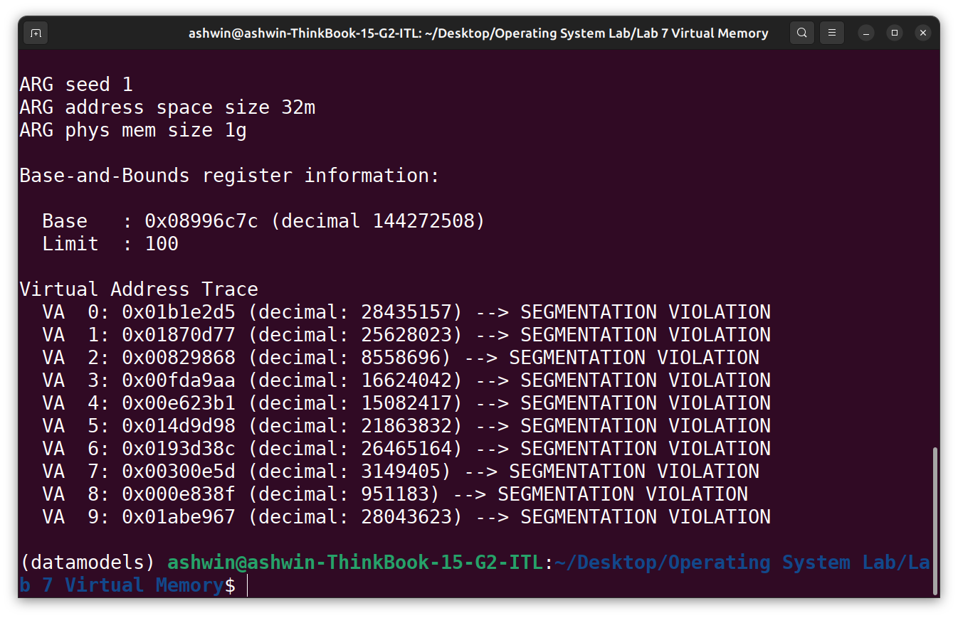
./relocation.py -s 1 -n 10 -l 100 -a 32m -p 1g -c

5) Here is a graph of valid fraction of randomly generated virtual addresses as a function of bounds register.
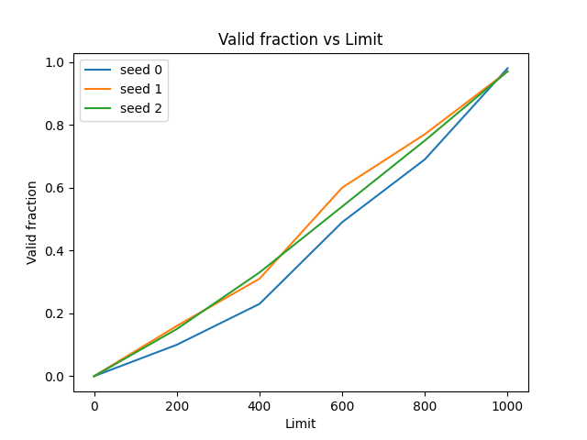

Part 2
1) Here address space size is 128 and physical memory size is 512. If vaddr < asize/2 Then virtual address falls under segment 0,
• In bound : vaddr < limit0 and paddr = vaddr + base0
• Out of bound : vaddr >= limit0
If vaddr >= asize/2 Then virtual address falls under segment 1,
• In bound : asize − limit1 =< vaddr and paddr = base1 − (asize − vaddr)
• Out of bound : asize − limit1 > vaddr
For seed 0:
Serial No | Virtual Address | Segment No | Within bounds?
0 | 108 | 1 | Yes
1 | 97 | 1 | No
2 | 53 | 0 | No
3 | 35 | 0 | No
4 | 65 | 1 | No

For serial number 0: Physical Address=Physical address size - (address space size – virtual address)
= 512 − (128 −108)
= 492

For seed 1:
Serial No | Virtual Address | Segment No | Within bounds?
0 | 17 | 0 | Yes
1 | 108 | 1 | Yes
2 | 97 | 1 | No
3 | 32 | 0 | No
4 | 63 | 0 | No

For serial number 0: Physical Address= 0 + Virtual Address
= 17

For serial number 1: Physical Address=Physical address size - (address space size – virtual address)
= 512 − (128 −108)
= 492
For seed 2:
Serial No | Virtual Address | Segment No | Within bounds?
0 | 122 | 1 | Yes
1 | 121 | 1 | Yes
2 | 7 | 0 | Yes
3 | 10 | 0 | Yes
4 | 106 | 1 | No

For serial number 0: Physical Address=Physical address size - (address space size – virtual address)
= 512 − (128 −122)
= 506
For serial number 1: Physical Address=Physical address size - (address space size – virtual address)
= 512 − (128 −121)
= 505
For serial number 2: Physical Address= 0 + Virtual Address
= 7
For serial number 3: Physical Address= 0 + Virtual Address
= 10

2) Highest legal virtual address in segment 0 is 19. Lowest legal virtual address in segment 1 is 108. Lowest illegal address 20. Highest illegal address 10.
To verify whether these values are correct, we execute the following command:
./segmentation.py -a 128 -p 512 -b 0 -l 20 -B 512 -L 20 -s 1 -A 19,108,20,107 -c

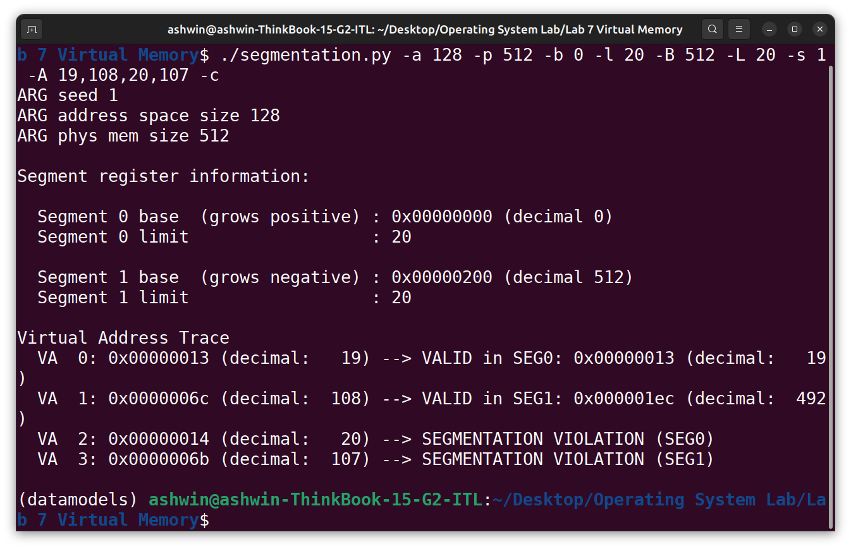

3) According to the question, virtual addresses 0, 1, 14, 15 are valid while rest of them are invalid. The first segment will contain virtual addresses 0-7 so base0 should be 0 and we want only 0 and 1 to be valid in this segment thus limit0 should be set to 2. Similarly, virtual addresses 8-15 belong to the second segment so base 1 should be 15 with a limit of 2.
Also proof the stated solution is given below:
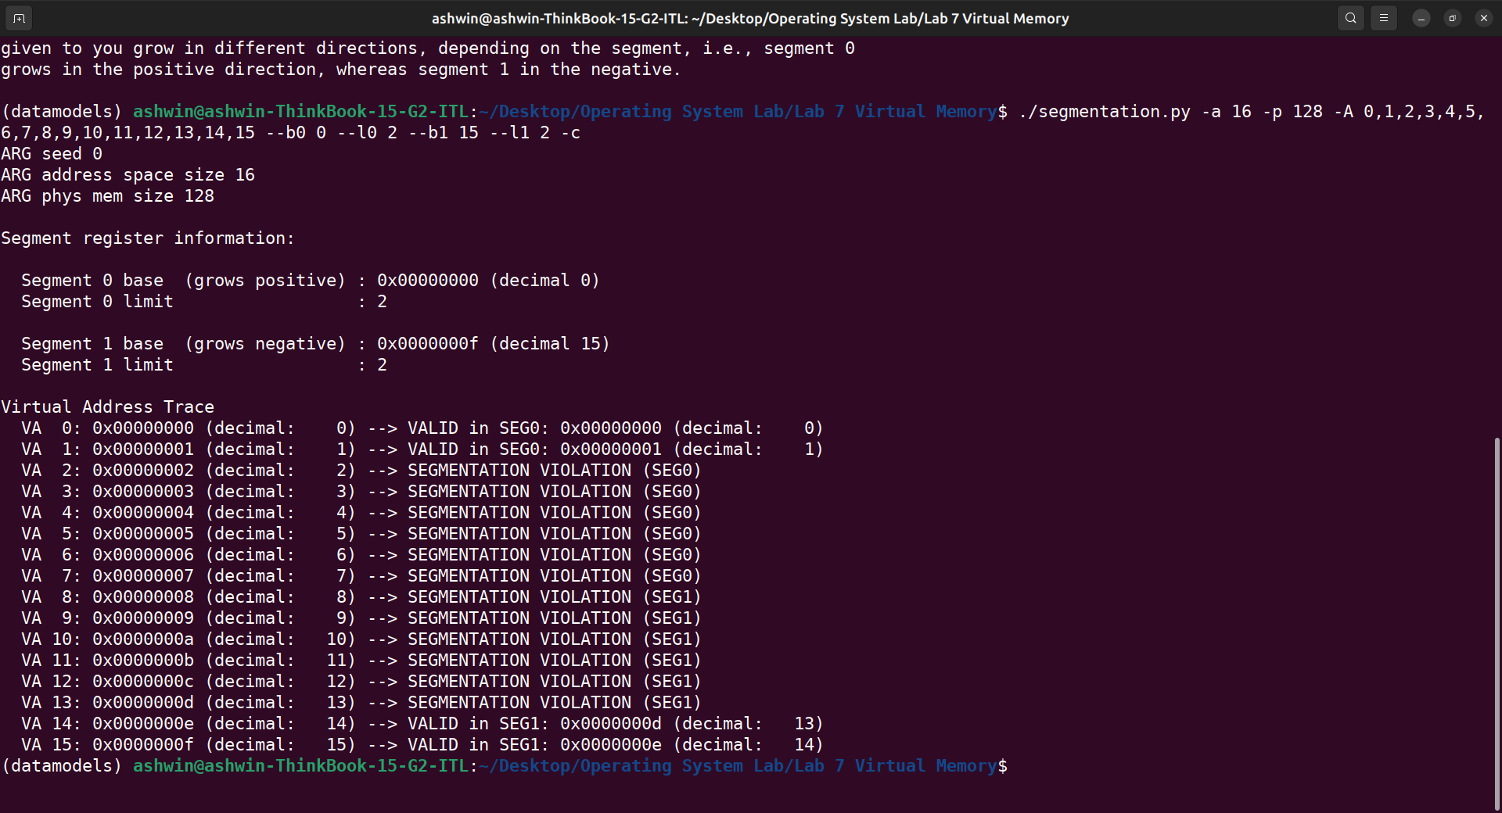
4) Let us take an address space of size 20 bytes and a physical memory os size 100 bytes. To generate a problem where roughly 90% of the generated virtual addresses are valid, we should set the valid memory size roughly 90% of the actual virtual memory size. Now, size of segment 0 + size of segment 1 = 90% of the address space = 0.9 * 20 = 18. Thus we could set base0 = 0, base1 = 20, limit0 = 9, limit1 = 9. In the following screenshot we can observe that 90% of the virtual addresses generated are valid. Here, base and limit parameters are important to obtain desired results.
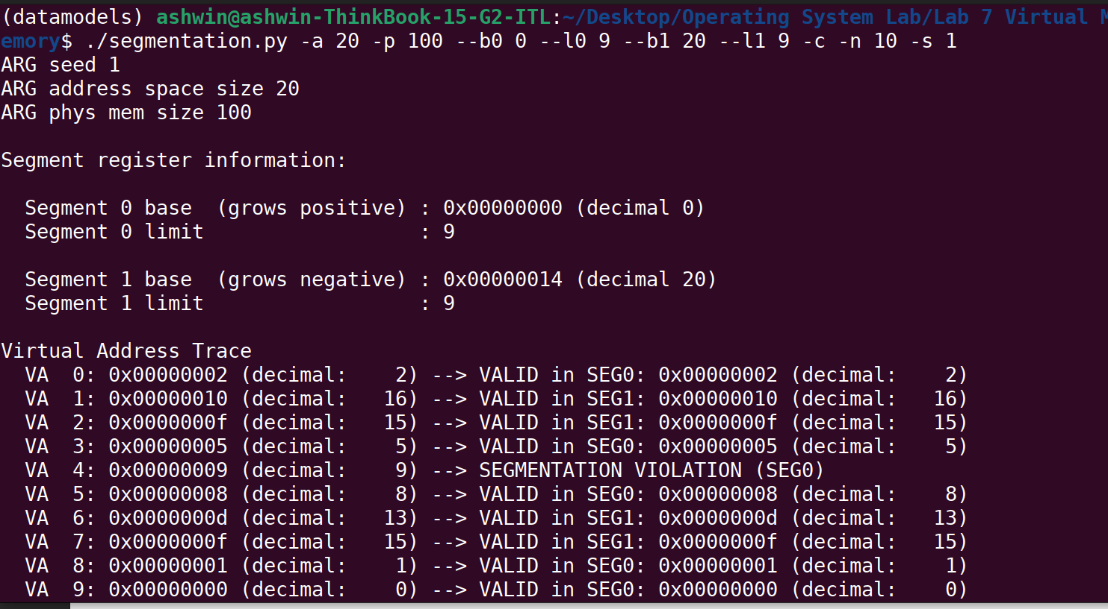

5) To obtain no valid virtual addresses we can set the parameters accordingly: base0 = 0, limit0=0, base1 = 15 and limit1 = 0. Thus there are no possible valid virtual addresses. Also, we can observe from the following screenshot.
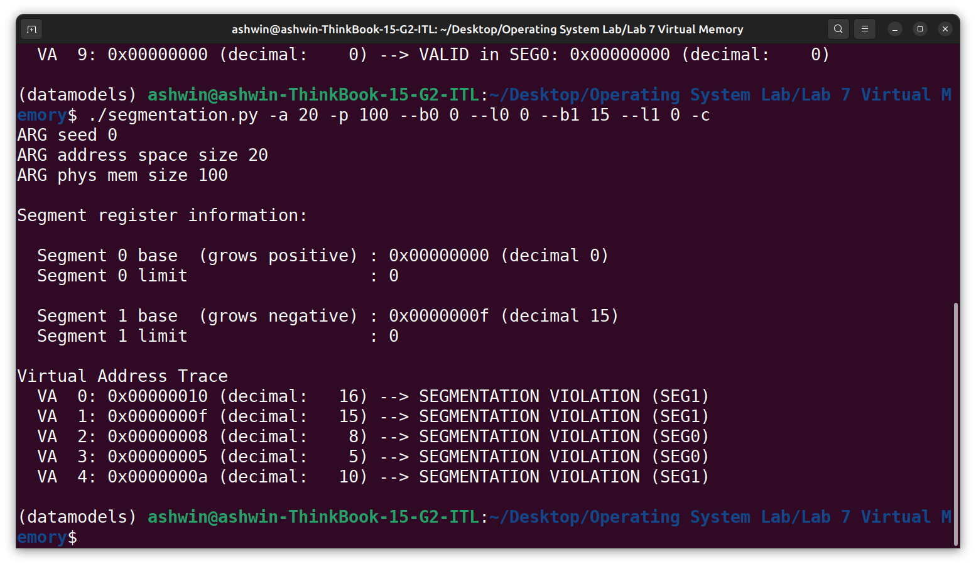
Part 3
1) The linear page table can be varied based on the following parameters:
a) Number of bits in the address space
Suppose the number of bits in the address space is 16.
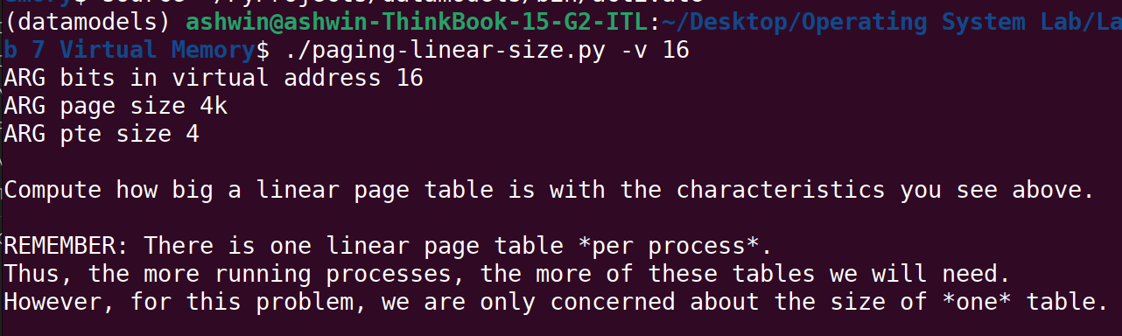
Page size = 4k = 4096 bytes = 2¹²
Number of bits needed in the offset = 12
Number of bits for the VPN = 4
Size of each page table entry = 4 bytes
Number of entries in the table = 2^{(number of VPN bits)} = 2⁴ = 16
Size of page table = (size of each page table entry) × (Number of entries in the table)
= 4 × 16
= 64 bytes

b) Page size
Suppose the page size is 32.
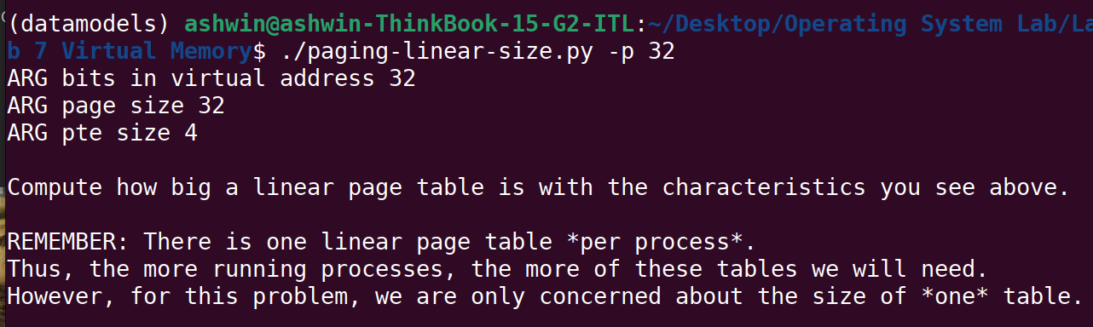
Page size = 32 bytes = 2⁵
Number of bits needed in the offset = 5
Number of bits for the VPN = 32 - 5 = 27
Size of each page table entry = 4 bytes
Number of entries in the table = 2^{(number of VPN bits)} = 2²⁷
Size of page table = (size of each page table entry) × (Number of entries in the table)
= 4 × 2²⁷ bytes

c) Page table entry size
Suppose the page table entry size is 16 bytes.
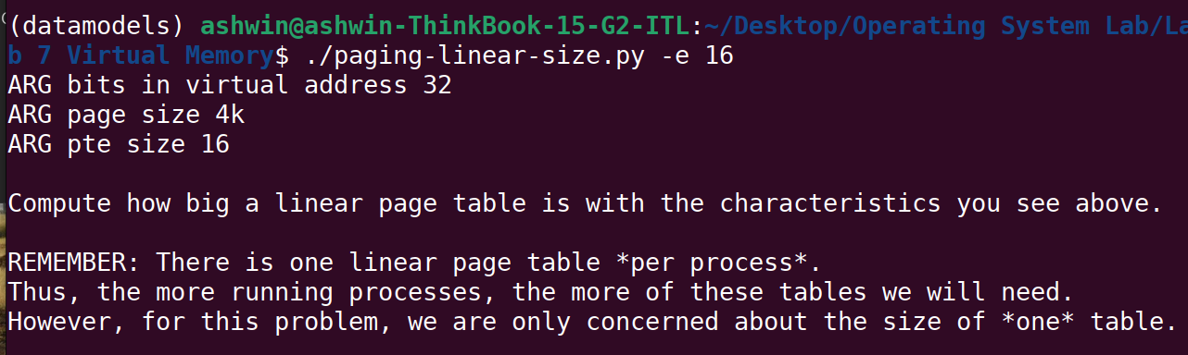
Page size = 4096 bytes = 2¹²
Number of bits needed in the offset = 12
Number of bits for the VPN = 32 - 12 = 20
Size of each page table entry = 16 bytes
Number of entries in the table = 2^{(number of VPN bits)} = 220
Size of page table = (size of each page table entry) × (Number of entries in the table)
= 16 × 2²⁰ bytes

Part 4
- From the flags:
-P 1k -a 1m -p 512m -v -n 0
-P 1k -a 2m -p 512m -v -n 0
-P 1k -a 4m -p 512m -v -n 0
we can observe that the address space is doubling with each flag. From the formulae:
Size of page table = (size of each page table entry) × (Number of entries in the table)
Number of entries in the table = (address space size) / (page size)
we can deduce that size of page table is directly proportional to address space size. Thus we can say that the page table size also doubles with each flag.
From the flags:
-P 1k -a 1m -p 512m -v -n 0
-P 2k -a 1m -p 512m -v -n 0
-P 4k -a 1m -p 512m -v -n 0
we can observe that size of page doubles with every flag. Also, from the above stated formulae, we can deduce that size of page table is inversely proportional to size of page. Thus we can say that size of page tables halves with every flag.
Larger page size will lead to less memory utilization as only one process takes lots of memory which goes unused. This unused space can be utilized by other process if the size of page is decreased.
- For the first command:
./paging-linear-translate.py -P 1k -a 16k -p 32k -v -c -u 0
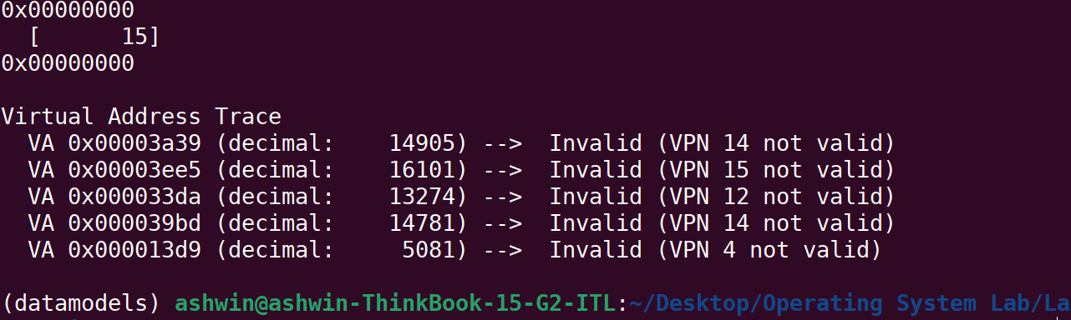
We can observe that all the virtual addresses generated are invalid.
For the second command:
./paging-linear-translate.py -P 1k -a 16k -p 32k -v -c -u 25
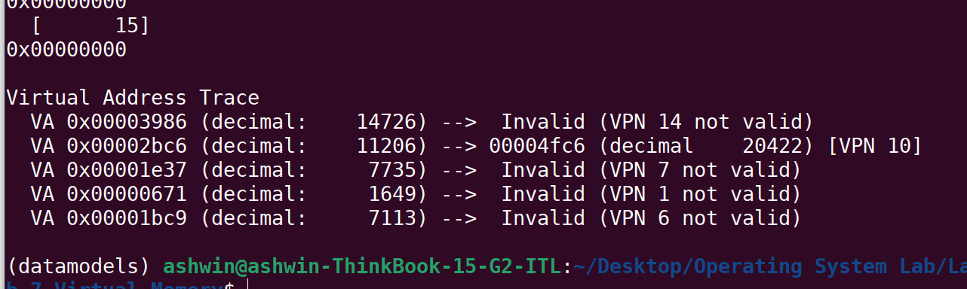
We can observe that one out of five virtual addresses generated is valid. Thus the percentage of valid addresses is roughly 20%.
For the third command:
./paging-linear-translate.py -P 1k -a 16k -p 32k -v -c -u 50
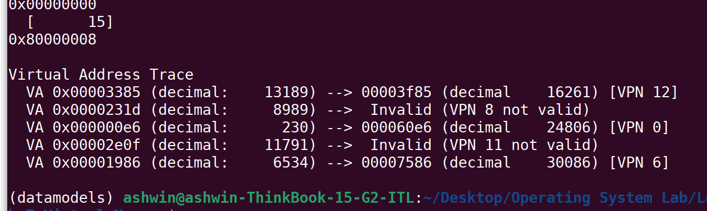
we can observe that there are 3 valid addresses out 5. Thus the percentage of valid addresses is roughly 60% now.
For the fourth command:
./paging-linear-translate.py -P 1k -a 16k -p 32k -v -c -u 75
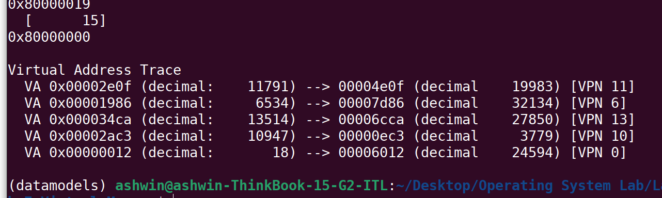
we can observe that all the virtual addresses generated are valid. Thus the percentage of valid addresses is roughly 100%.
For the last command:
./paging-linear-translate.py -P 1k -a 16k -p 32k -v -c -u 100
we can observe that all the virtual addresses generated are valid. Thus the percentage of valid addresses is roughly 100%. From this we can conclude that as we increase the percentage of pages that are allocated in each address space, the percentage of valid virtual addresses also increases.
- For the command:
./paging-linear-translate.py -P 8 -a 32 -p 1024 -v -s 1
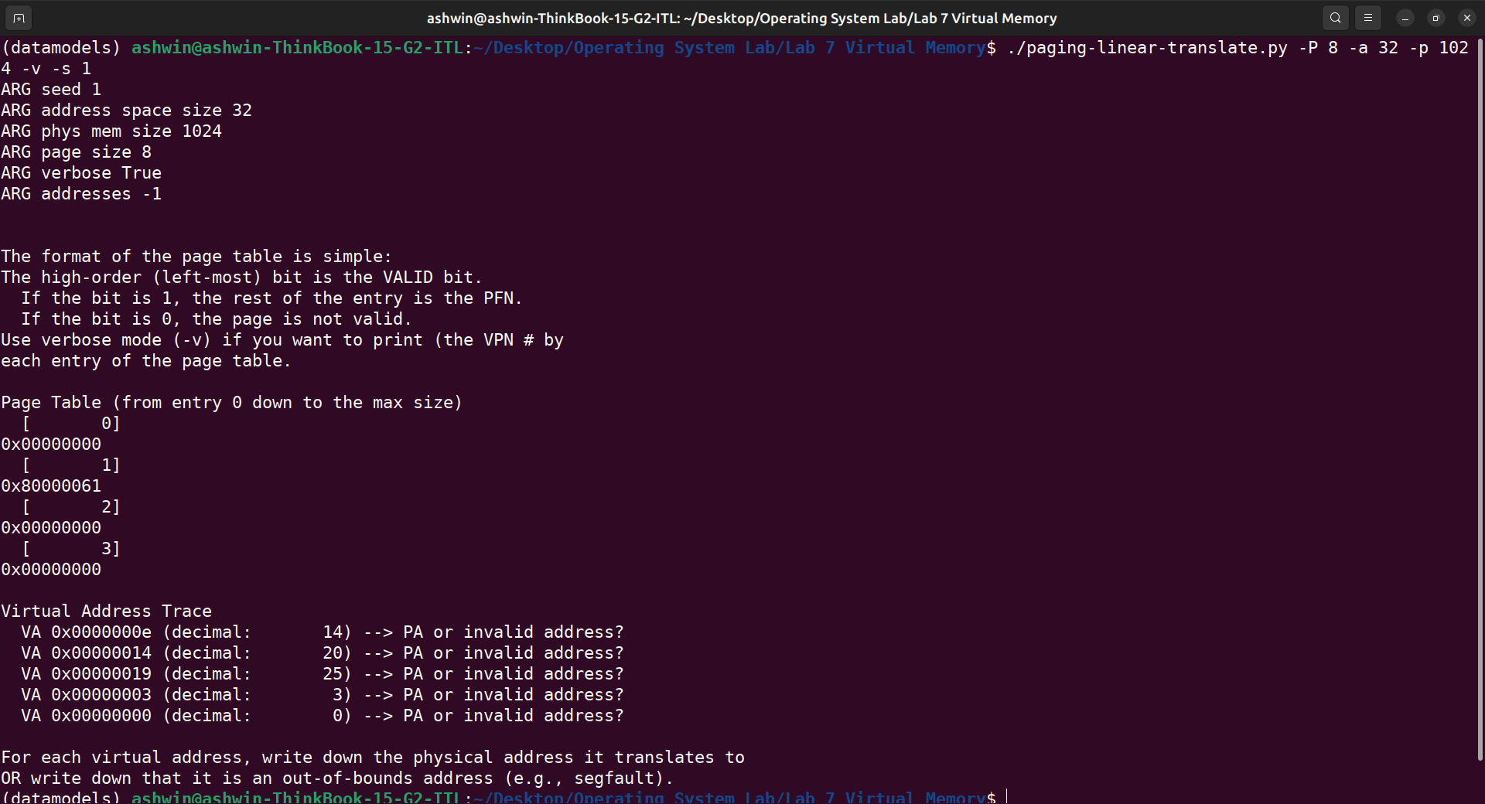

This page table is very tiny with 4 page entries of size 8 bytes each so, this page table is unrealistically small.
For the command:
./paging-linear-translate.py -P 8k -a 32k -p 1m -v -s 2
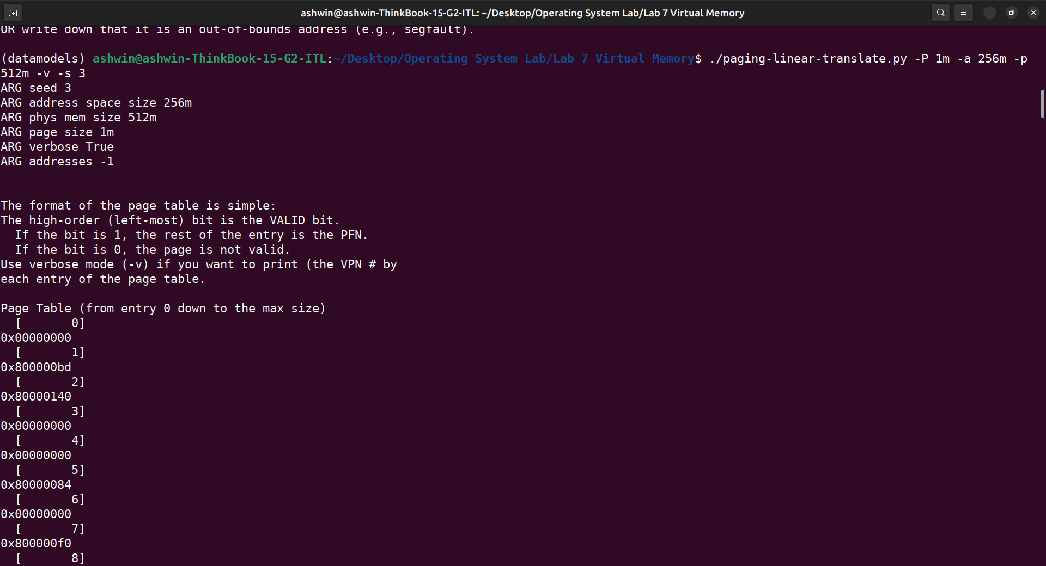

This combination of parameters are unrealistic as the size of page is too large.
- The program does not work when the page is bigger than address space size. Suppose we set page size as 16k and address space size as 8k then:
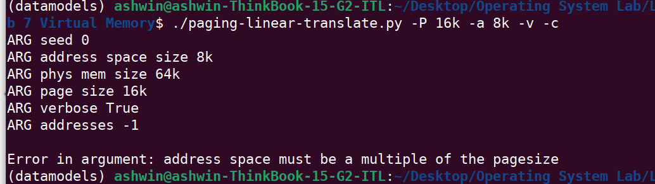
as we can see, there is an error.
The program also does not work when the physical memory size is less or equal to the address space size.
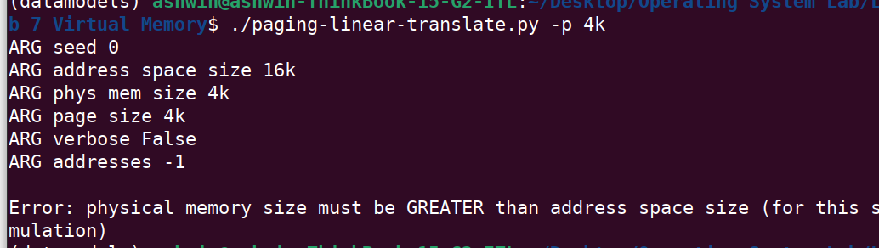

And finally, for the program to work, the address space must be a power of 2.
